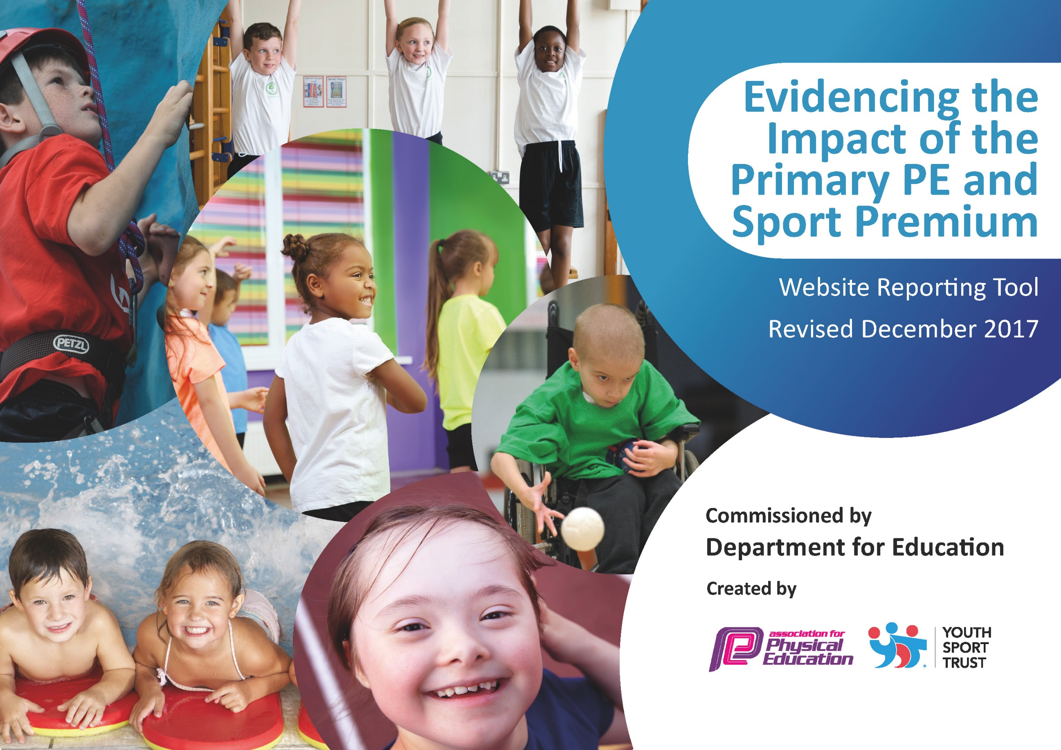

SPORTS PREMIUM ACTION PLAN 2022-23

DRAFT
Key achievements to date: | Areas for further improvement and baseline evidence of need:
Bronze Award Sainsbury’s school games mark 2014/15
Silver Award Sainsbury’s school games mark 2015/16
Gold Award Sainsbury’s school games mark 2016/17
Black Country commitment award for PE and school sport 2019/20
Gold Award Sainsbury’s school games mark 2021/22

Meeting national curriculum requirements for swimming and water safety | Please complete all of the below*:
What percentage of your current Year 6 cohort swim competently, confidently and proficiently over a distance of at least 25m? | 44%
What percentage of your current Year 6 cohort use a range of strokes effectively [for example, front crawl, backstroke and breaststroke]? | 44%
What percentage of your current Year 6 cohort perform safe self-rescue in different water-based situations? | 44%
Schools can choose to use the Primary PE and Sport Premium to provide additional provision for swimming but this must be for activity over and above the national curriculum requirements. Have you used it in this way? | Extra Provision provided
*Schools may wish to provide this information in April, just before the publication deadline.

Action Plan and Budget Tracking

Academic Year: 2022/23 | Total fund allocated: £19,598 | Date Updated:
Key indicator 1: The engagement of all pupils in regular physical activity – Chief Medical Officer guidelines recommend that primary school children undertake at least 30 minutes of physical activity a day in school |  |  |  | Percentage of total allocation:
 |  |  |  | %
School focus with clarity on intended impact on pupils: | Actions to achieve: | Funding allocated: | Evidence and impact: | Sustainability and suggested next steps:
All children to be physically active in school for 30 minutes each day.  To encourage and promote children to be physically active for at least 30 minutes daily at home.  To encourage all children to be physically active for 30 minutes at home | Every child takes part in two P.E. lessons a week.  After school clubs provided for years 1-6.  Classes rewarded weekly for extra physical activity.  TT attended teach active course (Physically active learning)  Mimove App purchased and integrated across school (starting with year 6)  Mimove to be integrated across school by the end of academic year.  Children to have access to resources and equipment which can be used to create their own games and enhance physical activity levels.  Play leaders role to be continued  TT to provide training to key lunchtime supervisors on how to play active games and use resources (early Spring) | £subsidy for PP children £1 a session  £subsidy for non PP children £2 per session  £2000  £5000 | We will be continuing to provide high quality PE and Sports opportunities during curriculum time, break and lunchtimes, and after school sessions  Regularly checking and monitoring classes physical activity levels.  Regularly checking and monitor Mimove app rewarding children with high engagement in physical activity. Identifying children who are not as physically active.  Year 5 to start using the Mimove app in spring term.  Play leaders will ensured all children have accessed outdoor play activities on a daily basis throughout the year. Children to be active throughout their lunch time. Move to in-house training 2023 onwards  Play equipment ready and available for lunch time use.  New storage for play equipment purchased.  New Play equipment to be purchased (Spring Term)
Key indicator 2: The profile of PE and sport being raised across the school as a tool for whole school improvement |  |  |  | Percentage of total allocation:
 |  |  |  | %
School focus with clarity on intended impact on pupils: | Actions to achieve: | Funding allocated: | Evidence and impact: | Sustainability and suggested next steps:
Encourage to take on leadership roles within sport.  Profile of sport to be raised through whole school focus days and assemblies and whole school workouts. | Sport captains and playground leads to be trained and assigned. To support the delivery of sport and physical activities.  Men’s FIFA World cup 2022 celebrated in school. Whole school assembly, opportunities to watch games children also completed learning activities based around the topic. |  | Sports captains and playground leaders have been given opportunities to lead sports and games.  TT has started Key Stage workouts at the end of playtimes.  Children able to talk about the men’s world cup and the countries that are taking part.

Key indicator 3: Increased confidence, knowledge and skills of all staff in teaching PE and sport |  |  |  | Percentage of total allocation:
 |  |  |  | %
School focus with clarity on intended  impact on pupils: | Actions to achieve: | Funding  allocated: | Evidence and impact: | Sustainability and suggested  next steps:
Develop staff confidence and knowledge working alongside Mr Tinsley (Sports specialist)  Promote sport as a priority.  School to remain in partnership with Dudley school sports network. | TT to be non-class based in order to lead sport and PE across the school.  Subject on a page created for PE to outline key objectives our intentions and how we plan to implement the curriculum across school.  Updated medium term plan to ensure a range of units are covered as skills are progressively taught.  PE lead to observe and team teach in PE lessons.  PE lead to mentor a member of staff each half term and a follow-up audit review to be completed.  TT to assist and planning and Assessment where necessary.  PE lead to provide Inset to support game skills progression -Sept 2022 (Subject overview discussed, schemes of work and planning)  Continue subscription to PE hub to ensure high quality lessons are planned that focus on progressive skills.  During Autumn 2 no pe lessons are to be rescheduled or cancelled due to Christmas production rehearsals  TT to attend sport network meeting for PE coordinators. | £2500 TLR  £900 PE Hub and Mimove | Staff have completed an audit evaluation after receiving mentoring and team teaching as a result staff knowledge and confidence has improved.  CE& RD both completed the mentoring programme in Autumn term (Year 2). After completing their audit review, both members of staff felt more confident in the sport of gymnastics and understood how to scaffold, break down skill and progress children’s learning. Both teacher’s feel more confident when teaching gymnastics.  TT has reviewed which units have been covered and which units worked well in order to plan next steps.
Key indicator 4: Broader experience of a range of sports and activities offered to all pupils |  |  |  | Percentage of total allocation:
 |  |  |  | %
School focus with clarity on intended  impact on pupils: | Actions to achieve: | Funding  allocated: | Evidence and impact: | Sustainability and suggested  next steps:
Children in Reception/Year1 to be able to ride a bike.  Increase participation and opportunities for girls’ sport in school.  Children to have access to a range of pe Lessons and range of equipment and resources.  Provide more structure and range to outdoor learning. | Balanceability (Provided by RB Gym and Sport).  Start a girls’ football team and enter a league competition (weekly training sessions provided)  Netball league resumed this academic year.(Weekly training sessions provided)  Volleyball introduce into Year 6 PE Curriculum.  Alternative sports week in summer term (Boccia equipment purchased)  TT to attend outdoor learning course.  Summer 2023 | £6080  £350 equipment | Twenty children from year 5/6 attended the trial.  After two successful rounds of trials twelve girls have been selected for the Girls football team.  23 children attending netball club (20 are female)  Volleyball equipment purchased
Key indicator 5: Increased participation in competitive sport |  |  |  | Percentage of total allocation:
 |  |  |  | %
School focus with clarity on intended  impact on pupils: | Actions to achieve: | Funding  allocated: | Evidence and impact: | Sustainability and suggested  next steps:
Staff availability, transportation to and from sports events will not present a barrier to participation. School will aim to achieve at least silver in school Games Mark.  All children to participate in Inter Competition | Release staff and hire transport to enable children to take part in inter-schools competitions. Pay for entry to relevant competitions. Mr Tinsley to ensure entry to all relevant competitions and to track competitions entered and ensure criteria for school games award.  School sports day (competitive)  Spring and Summer Term inter-house competitions to start | £850 | Yearly competitive leagues entered: Boys football, girls football and Netball  Autumn term competitions Year 5/6 Cross county All children ran well two pupils came 5th and 16th out of 100 competitors. Year 5/6 Tag rugby 3rd place out of 12 schools. Year 2 Multi skills second place out of 7 schools. Girls and Boys football 7aside tournament cancelled.  Spring term competitions: 5/6 Indoor sports Hall athletics. 3/6 Boccia. Netball 5/6

